DIGITAL LITERACY PROJECT REPORT

Sparsh Kumar Suman
Registration Number: 24BAI10205
Branch: Artificial Intelligence & Machine Learning
Year: 2nd Year
Course Code: CSE0001
Course Title: Digital Literacy
University: VIT Bhopal
Date: March 31, 2026

Introduction
I never really thought much about digital literacy until I started college. Like most students, I used social media and messaging apps daily but didn't consider how my online presence might affect my future career. This project changed that perspective completely. Working through these five tasks helped me understand that being digitally literate isn't just about knowing how to use technology—it's about using it safely, professionally, and effectively. As someone studying AI & ML, I realized I need to be extra careful about my digital footprint since tech recruiters definitely check online profiles. This report documents everything I built and learned while completing the Student Digital Ambassador assignment.

Task 1 Write-up: Digital Literacy Infographic
For this task, I used Canva to create a one-page infographic covering three main areas: what digital literacy actually means (beyond just "knowing computers"), safe internet practices for college students, and why a professional online presence matters even when you're still studying. I included icons for things like two-factor authentication and password managers because visual elements make people actually look at the content.
The tricky part was fitting everything on one page while keeping it readable. I initially tried to cram in five topics but it looked messy, so I narrowed it down to the three most important ones. I also struggled a bit with the color scheme—bright colors looked unprofessional, but too dull and nobody would notice it. Eventually settled on a blue-white combination that looks clean. Making this infographic taught me that explaining concepts visually is harder than it looks.
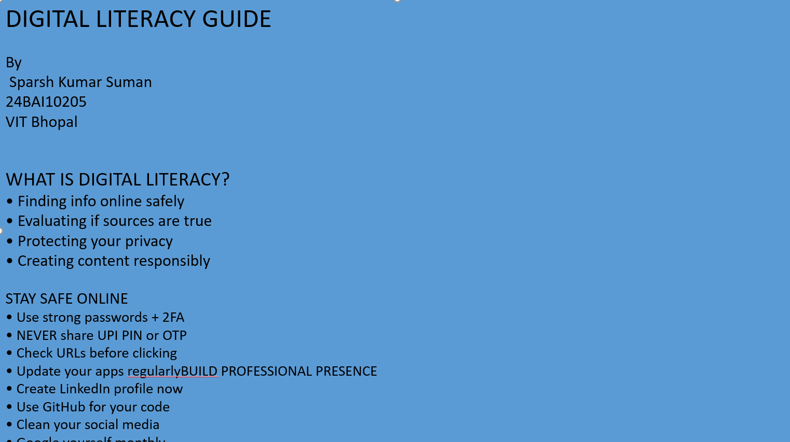
Task 2 Write-up: Building My Digital Portfolio
I chose three platforms for this task: GitHub, LinkedIn, and Kaggle. Each serves a different purpose for an AI/ML student like me. GitHub was the easiest since I already had an account at https://github.com/SparshSuman2005. I created a profile README with my basic info—name, that I'm in 2nd year AIML at VIT Bhopal, and that I'm currently learning Python for data science. It's simple but at least shows I'm active.
LinkedIn was completely new territory. I made my profile at https://www.linkedin.com/in/sparsh-kumar-suman-50b77a359 just a few months ago and honestly didn't see the point at first. But while filling out the education section with VIT Bhopal details and my expected graduation year (2028), I realized this is where recruiters actually look. Kaggle is something I joined recently because our seniors said it's essential for data science. I'm still in the learning phase there—just browsing datasets and trying to understand how competitions work.
Over the next four years, I plan to use GitHub for all my project code, LinkedIn for connecting with industry people and showcasing achievements, and Kaggle to build my data science portfolio. Right now it feels like I'm just setting up the foundation, but I know these platforms will matter when I start applying for internships.
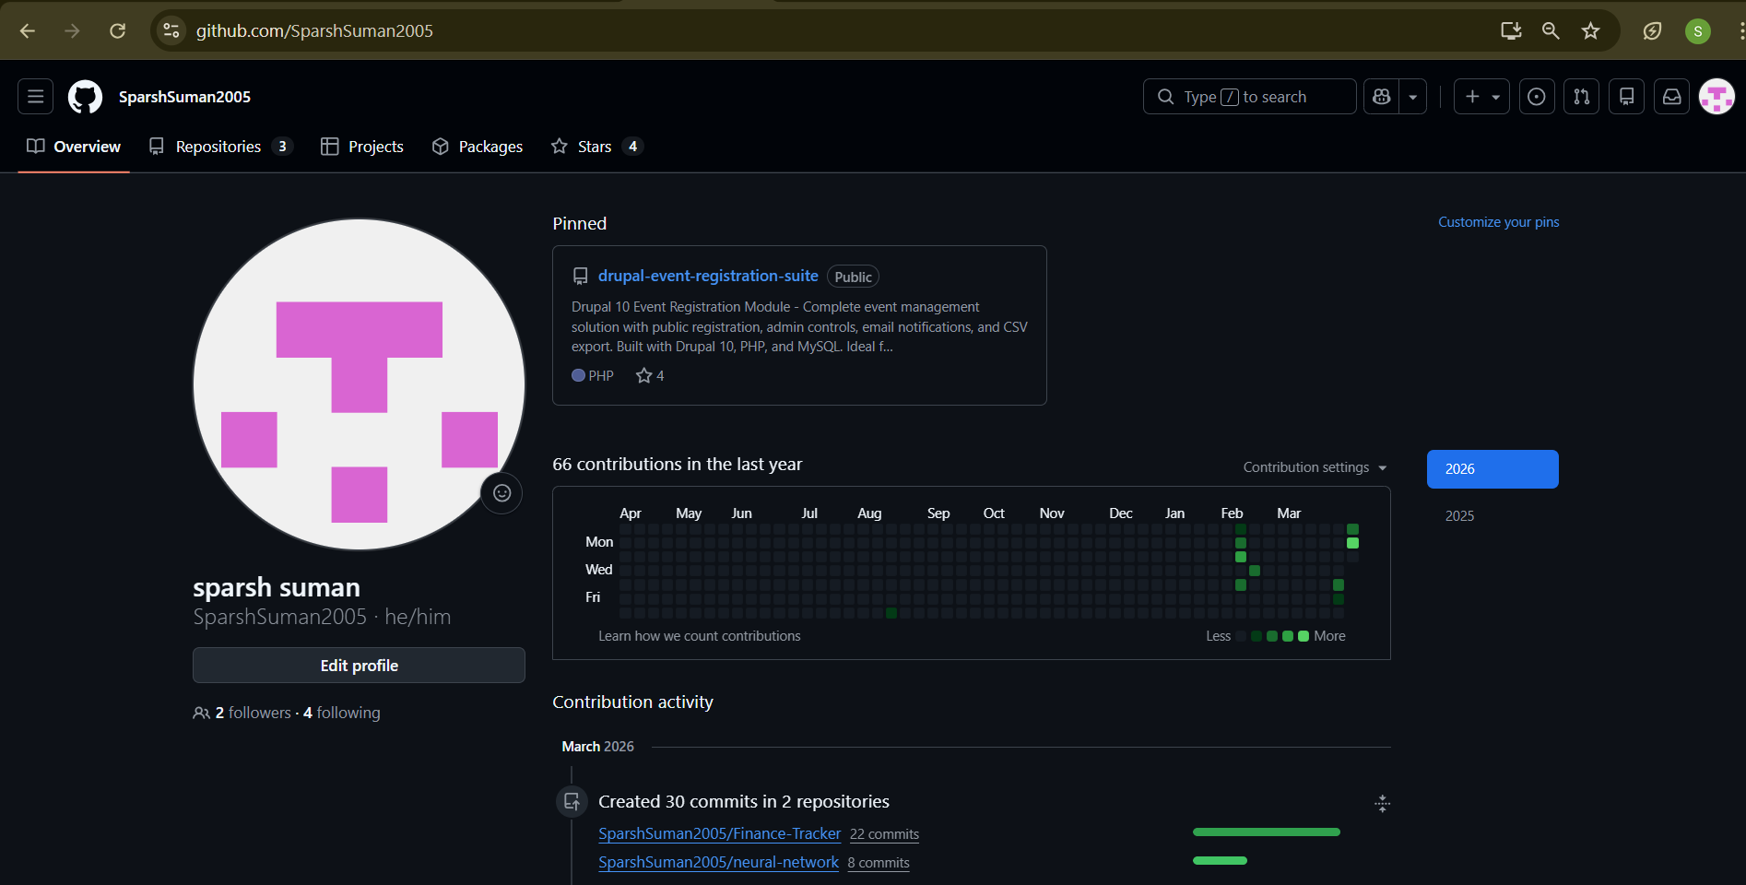
Task 3 Write-up: Exploring Platforms
For the coding part, I used HackerRank because the interface felt less intimidating than some other platforms. I completed the "Solve Me First" problem in Python, which is basically just adding two numbers. Sounds simple, but it helped me get familiar with how the platform works—reading input, processing it, and returning output in the exact format they want. I also tried the Python Introduction challenge and got a badge for it, which felt like a small win even though it was beginner level.
The Google Form was more interesting because I actually designed it to use with my batchmates. I created a 5-question "Digital Literacy Awareness Quiz" with one multiple choice question about identifying phishing emails, one short answer asking what they'd do if they got a suspicious link, and three other questions covering password safety, social media privacy, and professional email etiquette. I linked it to a Google Sheet so responses get recorded automatically.
These tools are definitely going to help me. HackerRank style platforms will improve my coding for AI/ML interviews, and knowing how to create forms and collect data is useful for research projects. The Google Form specifically could actually help me fulfill the Digital Ambassador role by identifying what my peers need to learn about digital safety.
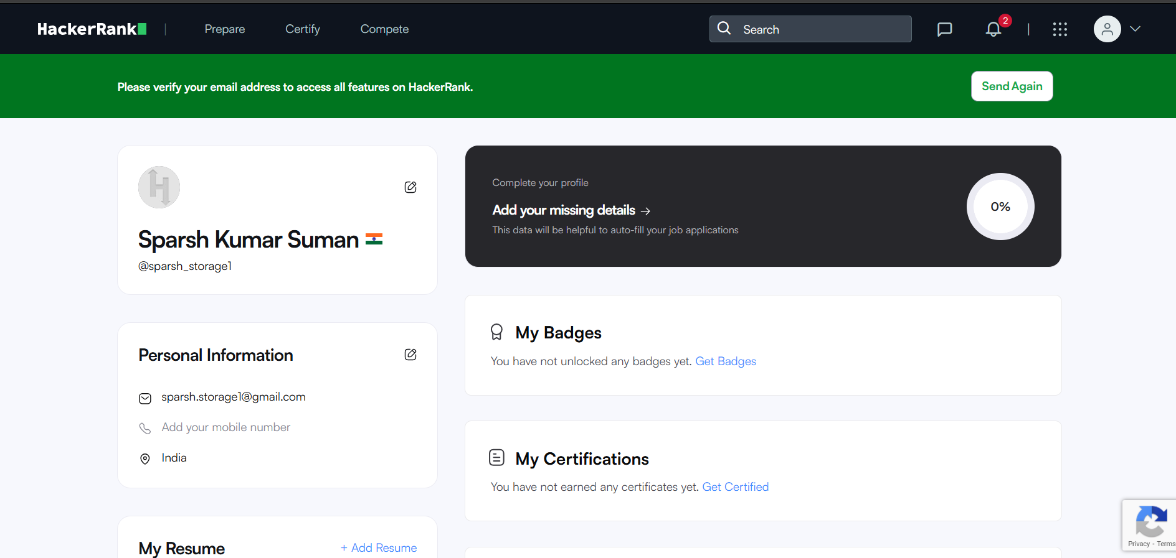
Task 4 Write-up: Email Etiquette
Writing professional emails felt awkward at first because I usually just text friends or use casual language on WhatsApp. But I drafted two emails: one requesting an assignment extension from a professor, and another expressing interest in a summer internship to a company coordinator. I kept them straightforward—clear subject lines, proper greetings, short bodies explaining exactly what I need, and professional sign-offs. No fancy language, just respectful and direct.
I also made a social media checklist with 5 Do's and 5 Don'ts for college students. The Do's include things like keeping profiles updated and thinking before posting; the Don'ts include oversharing personal location details and posting when angry.
For the reflection, I thought about a real situation where poor communication caused problems. Last year, a student in my department sent an angry email to a professor using all caps and slang because he was frustrated about grades. The professor didn't respond, and the student had to apologize later in person. It was embarrassing and probably damaged their relationship with that faculty member. If they had waited an hour and re-read the email, or shown it to a friend first, they could have avoided that. Digital communication is permanent, so taking a moment to think before hitting send is crucial.

Task 5 Write-up: Cybercrime Awareness
I chose UPI fraud because I've actually encountered it—almost fell for it once. Last year, I got a message saying I won a prize and needed to pay a "processing fee" via UPI to claim it. Something felt off so I ignored it, but later learned it was a common scam. Researching this topic showed me exactly how close I came to losing money.
What surprised me was how sophisticated these scams have become. It's not just random emails anymore—they use fake apps that look exactly like real banking apps, or call pretending to be from your bank with all your correct personal details. The fact that they specifically target college students who are often new to digital payments really bothered me.
One habit I'm changing: I never checked my bank statements regularly before, maybe once a month if I remembered. Now I review them weekly. I also installed the official cyber crime reporting app and saved the helpline number 1930. The case study I wrote follows a realistic scenario where a student loses ₹15,000 to a fake "electricity bill" payment link, which could happen to anyone not paying attention.

Conclusion
Working on this project changed how I view my online presence. I went from thinking LinkedIn was unnecessary to actively maintaining a profile, and from ignoring suspicious links to understanding exactly how dangerous they can be. The coding practice and email drafting felt like practical skills I'll actually use, not just assignment tasks. As a 2nd year AI/ML student, having this foundation in digital literacy feels essential—both for my career and personal safety. My GitHub repo now has actual content, I know how to write a proper professional email, and I'm much more aware of cyber threats. Overall, this wasn't just about getting marks; it was about becoming someone who can actually help peers navigate digital spaces safely.
References
1. Canva. (2026). Graphic Design Platform. Retrieved from https://www.canva.com
2. GitHub. (2026). Code Repository and Version Control. Retrieved from https://github.com
3. HackerRank. (2026). Coding Practice Platform. Retrieved from https://www.hackerrank.com
4. LinkedIn Corporation. (2026). Professional Networking Platform. Retrieved from https://www.linkedin.com
5. National Cyber Crime Portal. (2026). Cyber Crime Reporting. Retrieved from https://cybercrime.gov.in
6. Ministry of Home Affairs, India. Cyber Crime Helpline 1930.
7. VIT Bhopal University. (2026). CSE0001 Digital Literacy Course Materials.

